Because the SLP instructions require the use of a different database (Oracle Enterprise and not Oracle Express) I have installed Oracle Enterprise.  
Now, when typing in <https://localhost:1158/em> , there’s a file that is downloaded named ‘em’.

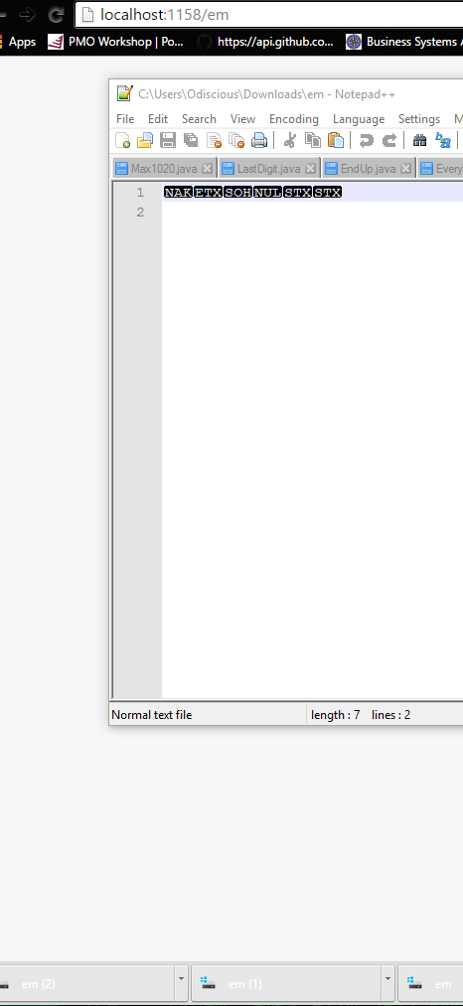

This is the site that I’ve been following for installation and setup for Oracle Enterprise.

<https://www.youtube.com/watch?v=3XcQvvHmIP0>

In taking the steps to connect the listener, I’ve realized that port 1521 is already in use by another program. (here’s the snapshot of my cmd console)

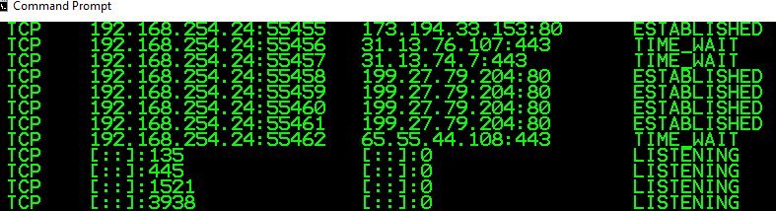

After getting this figured out, I’ll need to configure the Local Net Service Name in Oracle Net Configuration Assistant

NOTE: PORTS 1158 AND 1521 ARE BOTH IN USE – last column on right is the PID (Process Identifier)



It appears that the Port 1158 is associate with a java.exe file located here:  
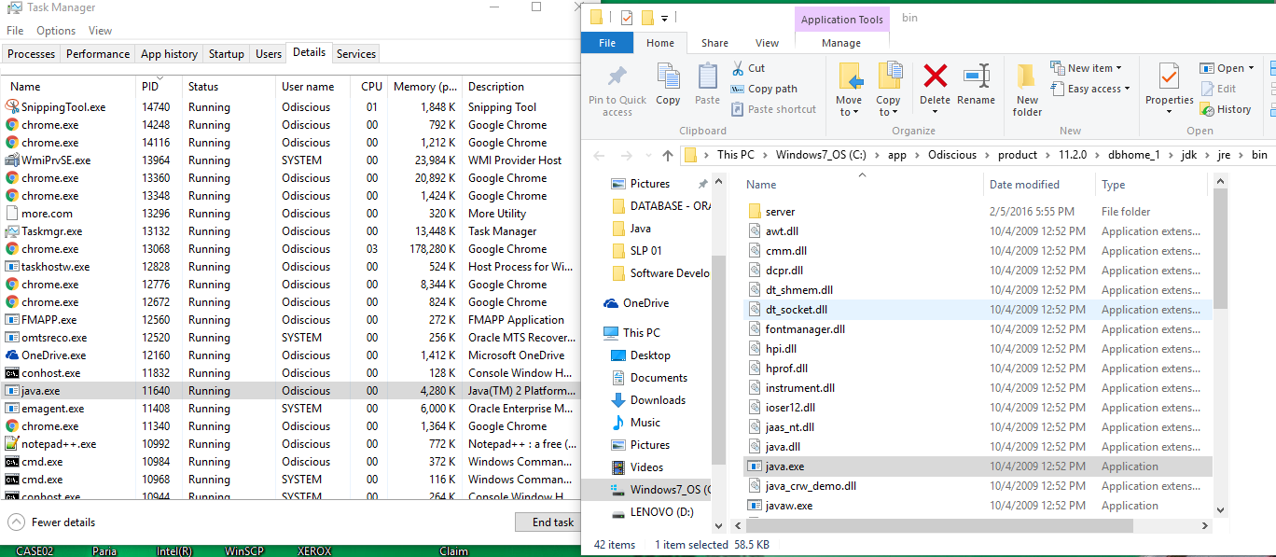

Port 1521 is located here:

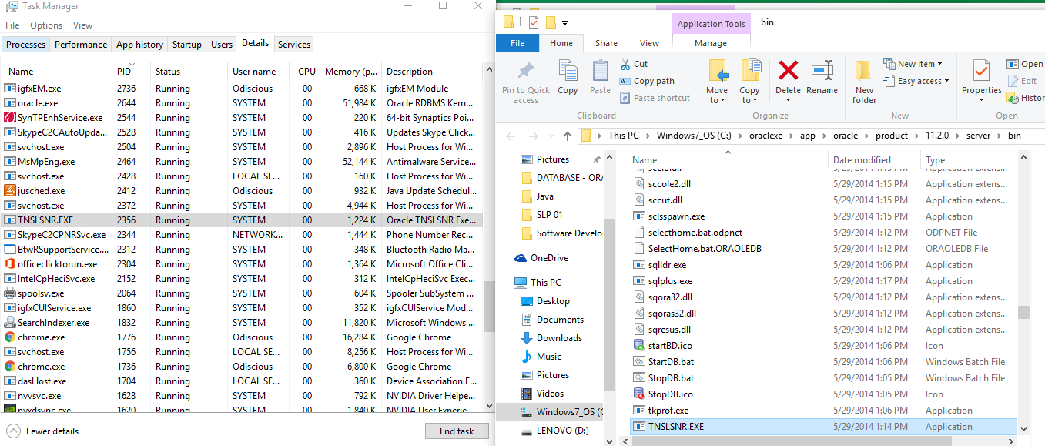

Based on this information, Oracle Express Edition is connected properly:

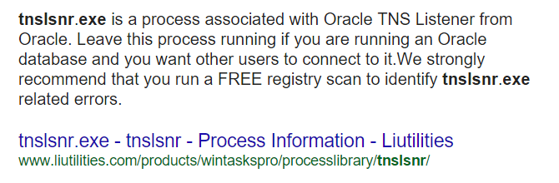

Find: When typing, localhost:1158/em into the URL… java.exe is called and an ‘em’ file is downloaded. I do not, currently, know what this means.

Additional documentation describing tnslsnr.exe, <http://www.file.info/windows/tnslsnr_exe.html>

Database Error:

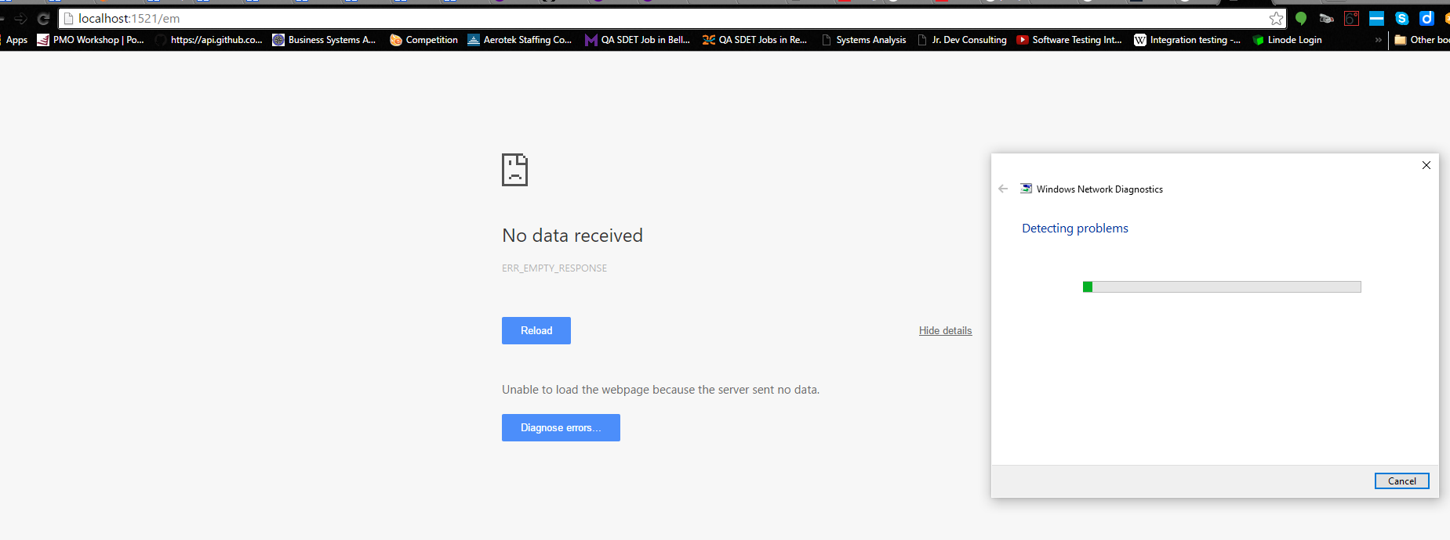

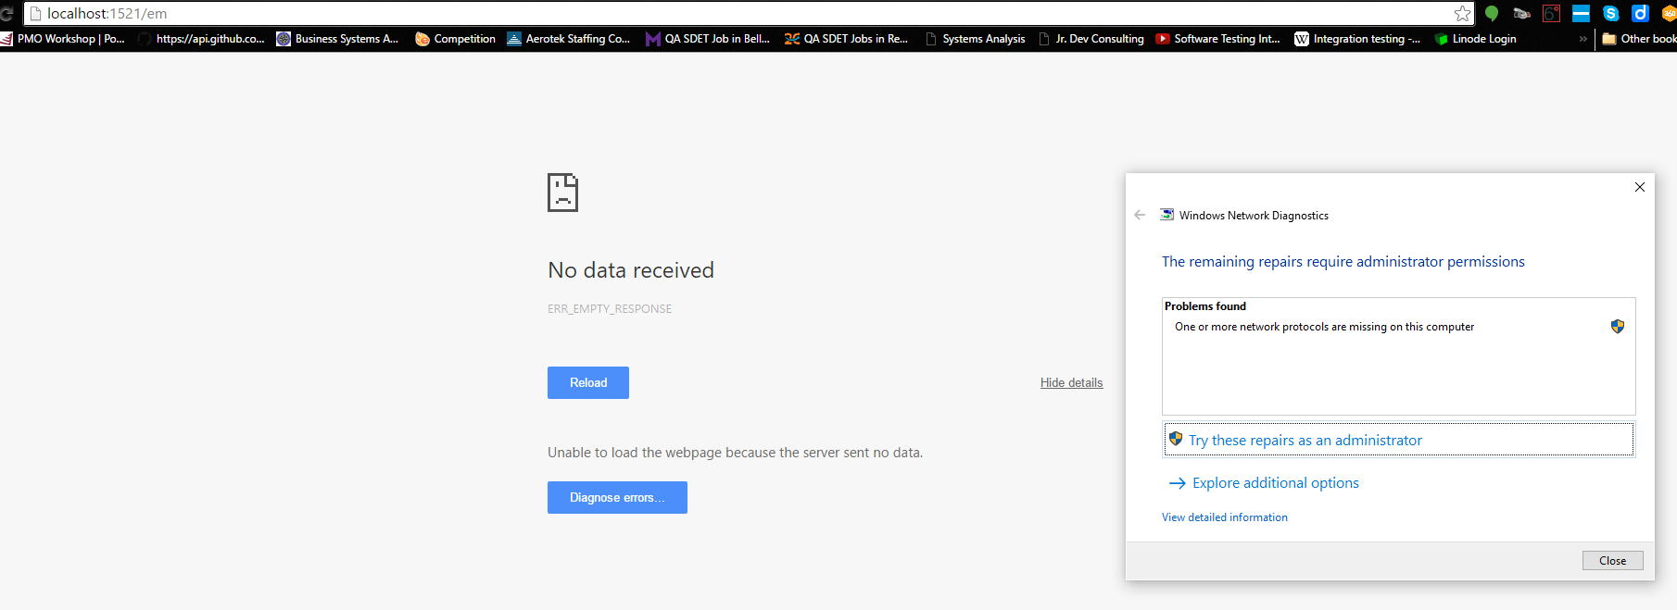

I can go no further on my own… assistance is required, please.

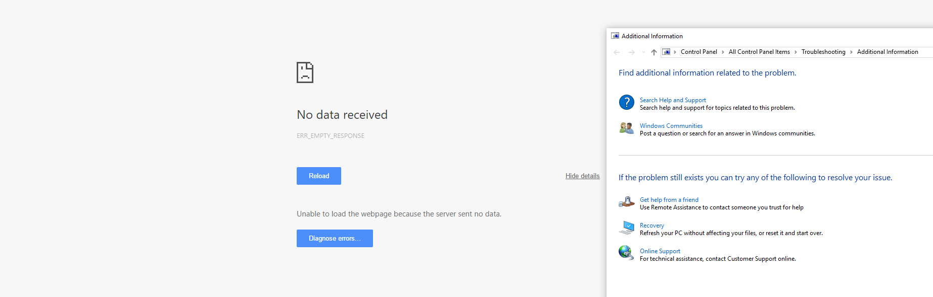

Update: I have been able to login using the browser, but Oracle SQL Developer can no longer connect to hr, oe, or SYS/SYSTEM. Troubleshooting suggests changing the port to, 1522 via webpage. It’s already there. Stuck again.

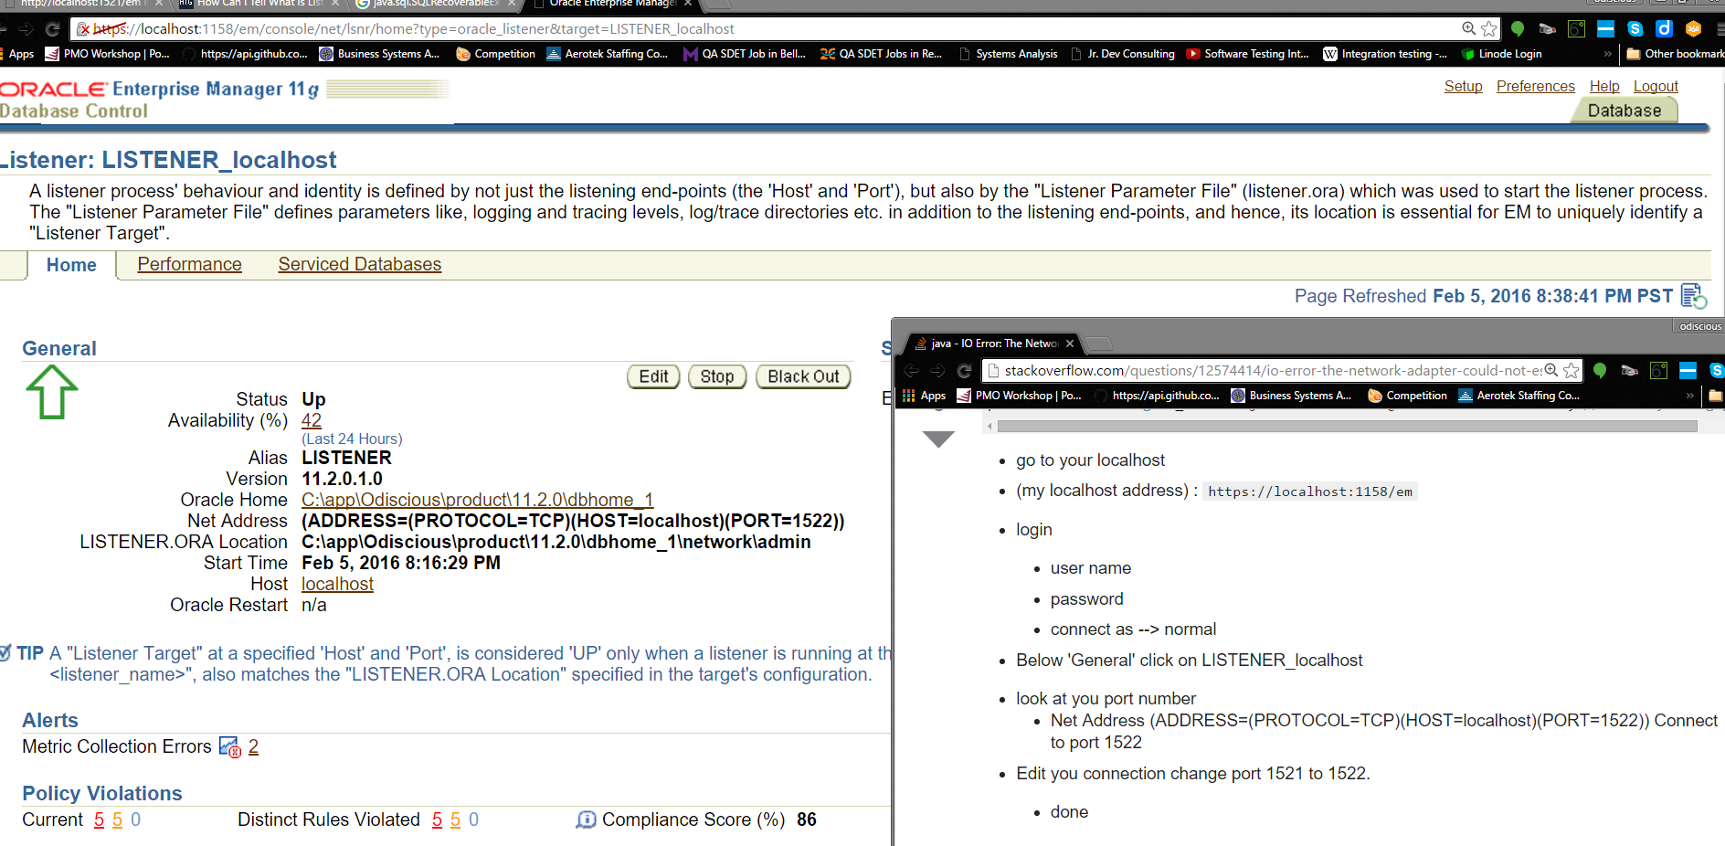

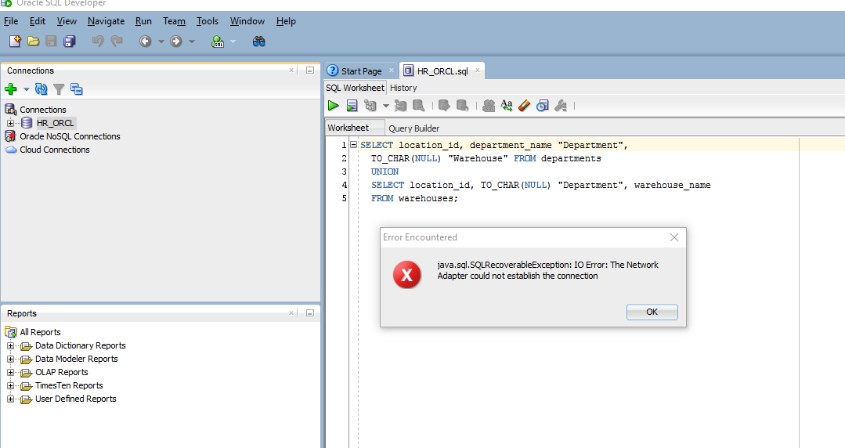

I have taken steps to validate active listener via cmd line by typing, lsnrctl status

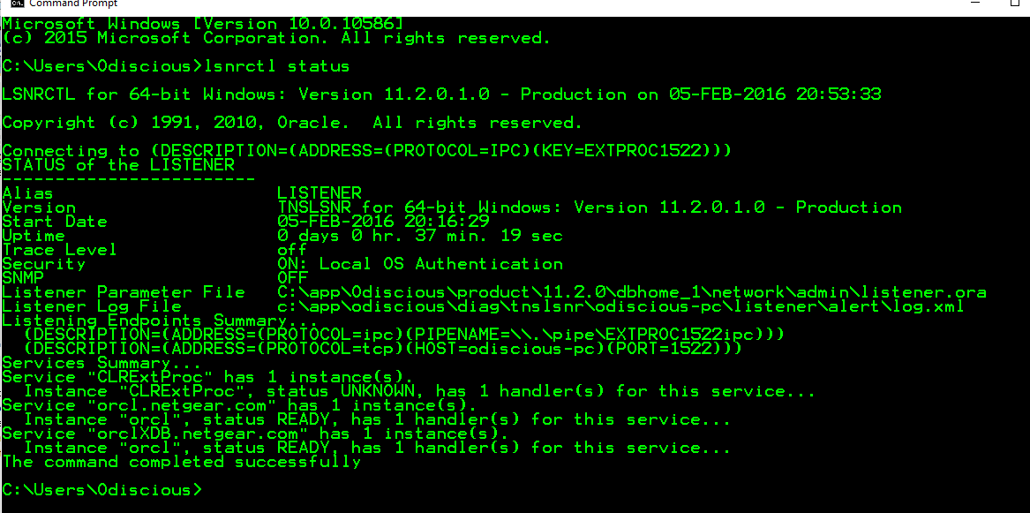

Because I cannot use Oracle SQL Developer to login into the database, I’m using the cmd prompt with the following sql command:

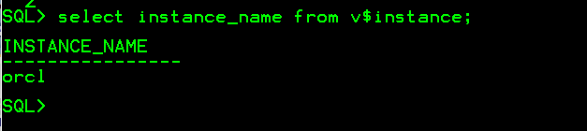

I have now been able to locate the SID and log into the database via port 1522

At this point, I do not know if the hr or oe databases exist in the current SID of orcl and I do not know where to install the XML files from SLP 01 into a working directory (where is the working directory or what is the name of it?).

